Special City Council Meeting
City Of Virden
City Council Chambers
Thursday July 20, 2023

Meeting called to order by Mayor Murphy at 6:46 pm.

Roll Call:
- The following Council Members were present: Bertolino, Boster, Calloway, Ibberson, Mitchell, Mottershaw, and Neighbors
- Absent: Cunningham
Also present were: Mayor Murphy, City Clerk Shelly Boster, Public Work director Gary Etter
- Visitor: Stephanie Ballinger

Topics:
- Discussion and acceptance of proposal from Louis Marsch, INC for oil and chip MFT maintenance work in the amount of $73,118.00
Motion made by Bertolino seconded by Mitchel to acceptance of bid proposal from Louis Marsch, INC for oil and chip MFT maintenance work in the amount of $73,118.00.
Discussion: This item had already been approved for up to $80,960.00 and came in under.
Motion passed with majority in favor. Ayes: Bertolino, Boster, Calloway, Ibberson, Mitchell, and Neighbors; Nays: Mottershaw; Absent: Cunningham; Abstain: None

- Discussion and acceptance of proposal from CASCO for crack sealing, sealcoating, and pavement marking MFT maintenance work in the amount of $148,605.70
Motion made by Bertolino seconded by Mitchell to acceptance of proposal from CASCO (Complete Asphalt Service Company) for crack sealing, sealcoating, and pavement marking MFT maintenance work in Mill Creek area and around the square for the amount of $148,605.70.
Discussion: An inquiry about South Dye. No bids have come in for those.
Motion passed with all in favor. Ayes: Bertolino, Boster, Calloway, Ibberson, Mitchell, Mottershaw, and Neighbors; Nays: None; Absent: Cunningham; Abstain: None

- Appoint and hire up to three persons for part-time dispatch
The appointment of Eddie Emery for part-time dispatch at the current rate of pay was made by Mayor Murphy.
Motion made by Mottershaw seconded by Boster to accept the appointment of Eddie Emery at the current rate of pay.
Discussion: None
Motion passed with all in favor. Ayes: Bertolino, Boster, Calloway, Ibberson, Mitchell, Mottershaw, and Neighbors; Nays: None; Absent: Cunningham; Abstain: None

The appointment of Jennifer Baker for part-time dispatch at the current rate of pay was made by Mayor Murphy.
Motion made by Boster seconded by Mitchell to accept the appointment of Jennifer Baker at the current rate of pay.
Discussion: The Chief and Dave Bounds will determine how and when the training will occur and when hours will be distributed.
Motion passed with majority in favor. Ayes: Boster, Calloway, Ibberson, Mitchell, Mottershaw, and Neighbors; Nays: Bertolino; Absent: Cunningham; Abstain: None

The appointment of Emily Forshee for part-time dispatch at the current rate of pay was made by Mayor Murphy.
Motion made by Mottershaw seconded by Boster to accept the appointment of Emily Forshee at the current rate of pay.
Discussion: The Chief and Dave Bounds will determine how and when the training will occur and when hours will be distributed. Training can be done on the day and second shift. Hours can be distributed. This is an intermittent part-time job to make some extra money.
Motion passed with majority in favor. Ayes: Bertolino, Boster, Calloway, Ibberson, Mitchell, and Neighbors; Nays: Mottershaw; Absent: Cunningham; Abstain: None

Executive Session:
- None

Additional:
None

Motion made by Mottershaw second by Neighbors to adjourn at 6:59 pm.
Discussion: None
Motion passed with all in favor. Ayes: Bertolino, Boster, Calloway, Ibberson, Mitchell, Mottershaw, and Neighbors; Nays: None; Absent: Cunningham; Abstain: None

Meeting adjourned at 6:59 pm.

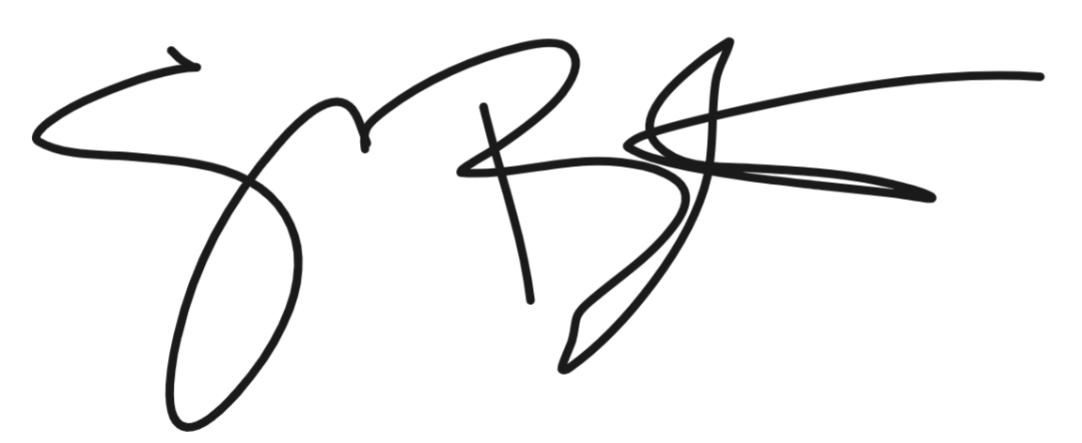
Shelly Boster
City Clerk

Date Minutes Approved: August 7, 2023

