Administration Committee Meeting
City Of Virden
City Council Chambers
Thursday, May 4, 2023

Meeting called to order by Alderman Mottershaw at 7:00 pm

Aldermen in attendance: Bertolino, Boster (late), Calloway, Cunningham, Ibberson, Mottershaw, and Neighbors

Also in attendance: Mayor Murphy (late)

Topics:
- Approval of meeting minutes 04/05/2023
Motion made by Mottershaw second by Bertolino to approve meeting minutes 04/05/2023. Motion passed with all in favor.

- Letter from Cravens Office
Mottershaw: We received a letter from our attorney. They have been City of Virden attorney for 4-5 years. They currently have $500.00 retainer. Don is $200.00/hr. and Joe is $180.00/hr. They would like to increase to $600.00 retainer and increase Don to $225.00/hr. and Joe to $200.00/hr.
Motion made by Bertolino seconded by Neighbors to recommend to council to approve suggested increase. Motion passed with all in favor.

- Sanitation District Contract
Murphy: The City of Virden water office does the billing for the Sanitary District. We are one of 5 communities in the State of Illinois that the Sanitary District is separate than the city. They have no way of metering how much waste. We do that for them by how much water used determines waste. The city meters the water, produce the bills, send out the bills, collects the money then distribute the money to the Sanitary District. I saw a contract from 2010 that the Sanitary District paid $1,800.00 a month. The contract states that we have to let them know one year ahead of time that we wish to terminate the contract. We let them know before April 30, 2023, that we planned to terminate the contract as of April 30, 2024, unless we could come to an agreement before then. Ibberson: Who makes up their board? Mottershaw: There are three. They are not elected. They are appointed by four legislators. Murphy: I looked at inflation rates since 2010 and it would come to $2,454.00. Mottershaw: To produce the bills, it cost a yearly Postage: $11,075.00, Meters: $30,000.00, Card stock: $1,049.00 Billing software: $5,398.00. Billing software membership and updates $1,344.00, Employee in the office: $46,000.00. Total: 94,866.00. Boster: I think we should think about getting rid of flat numbers and work in percentages. Cunningham: I think that should be detailed out in the new contract. Then figure out what percentage we would like reimbursed. Also, if left as an automatic renewal have a percentage increase on the renewal. Bertolino: We need to think about some language for the contract and what we may want to increase it to. We know we weren’t going to come to a consensus tonight. Mottershaw: Also do some thinking on how often we want to adjust the rate.

- Electric Rates
Mottershaw: I spoke with Grant Barfuss with Constellation. Currently we are paying market rates. We can see how the market does. Currently rates have dropped. We can continue to pay market rates and they may go up or they may come down or we can lock in rate with Constellation. Boster: All city building meters will be at this rate? Mottershaw: Yes. Boster: My recommendation would be to do 44 months. All: Agreed to lock in at 44 months and put on the agenda for council. Mottershaw: I will call for the rate right before the next council meeting. That way we will know the rate if we choose to vote at council.

- Discuss application for boring permit
Mottershaw: Ordinance they must start restoration within 60 days of completion or at 6 months if it is long project. With the application they have to turn in a map to show proposed routes, junction box locations, and/or any above structures. It also has the contractor and the owner, and the application requires both be listed with contact information. The Public Works director then will have to approve the boring and take it to the Public Works committee meeting and the committee will recommend for council to approve the permit. One the permit is approved by the council it requires a $5,000.00 deposit for the first 10 blocks of boring and each additional block is $300.00. They have to provide liability insurance of $1,000,000.00 that is required to go into effect two months after anticipated completion date along with $20,000.00 bond for 2 years to cover any issues. If they do not follow the contract, the Public Works director can suspend the work. Cunningham: Does the application have it where they state they will comply with City of Virden ordinances. Bertolino: Last paragraph on the second page. Cunningham: There is a typo on last page #2 it says competition and should be completion. Ibberson: We think $20,000 for the bond will cover? Mottershaw: This is what the lawyer recommended. We can choose to change it later if needed. Everyone ok with the application with the changes and on letterhead. All: Yes

Executive Session
- None

Additional Items:
- None

Motion made by Mottershaw seconded by Bertolino to adjourn at 8:36 pm. Motion passed with all in favor.

Meeting adjourned at 8:36 pm.

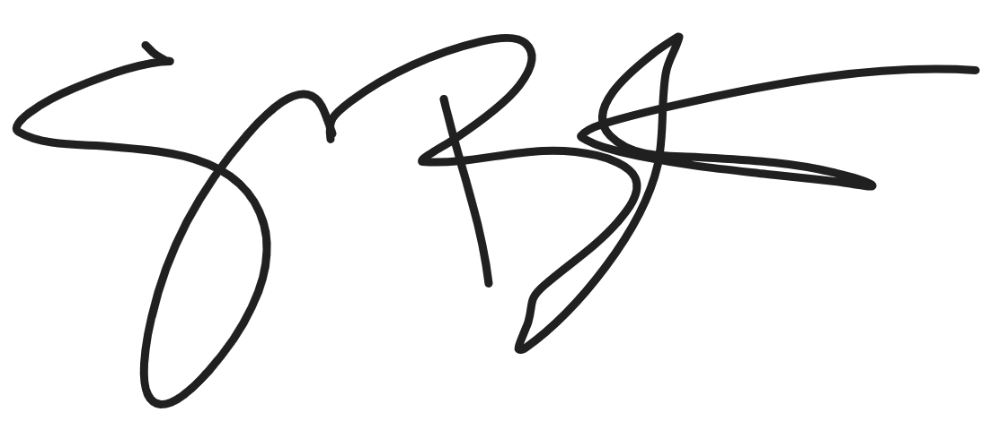
Shelly Boster
City Clerk

Date Minutes Approved: 6/1/2023

