Finance Committee Meeting
City Of Virden
City Council Chambers
Thursday May 25, 2023

Meeting called to order by Alderman Mottershaw at 6:48 pm.

Aldermen in attendance: Bertolino, Boster, Cunningham, Ibberson, Mitchell, and Mottershaw. Calloway and Calloway arrived after the start of the meeting.

Additional in attendance were: Mayor George Murphy, Chief Snodgrass, and Dispatch Manager Dave Bounds. Deputy Treasurer/Bookkeeper Barry Liss arrived after the start of the meeting.

Topics:
- Approval of Meeting Minutes 4-27-2023:
Motion made by Mitchell seconded by Mottershaw to approve the 4-27-2023 Finance Committee Meeting Minutes. Motion passed with all in favor.

- Discuss $1000.00 deductible for coverage under lawsuit claim
Mottershaw: We had a lawsuit last year. The insurance company took to court to have it dismissed. It was dismissed. The insurance company’s expenses our deductible goes against that.
Motion made by Mottershaw seconded by Neighbors to recommend to council to authorize the payment of $1,000.00 deductible to insurance company. Motion passed with all in favor.

- April 2023 Treasurer’s Report
Liss: I apologize for the formatting of the printed copy.
Motion made by Mottershaw seconded by Boster to recommend to council to approve treasurer reports for April 2023. Motion passed with all in favor.

- Discuss fund for PayCourt
Mottershaw: We use PayCourt to collect monies owed to the city. We are going to start having the bills for the clean-ups go to the collection agency. With PayCourt there is no expense to the city, they keep 1/3 of what they collect. Jessica was wondering what account that would need to go into. I was thinking we would set up a separate account instead of it going into our general corporate account. Liss: I think that would work.
Motion made by Mottershaw seconded by Murphy to recommend to council to approve setting up a savings account with Prairie Bank and Trust to have any collections from PayCourt deposited into. Motion passed with all in favor.

- Set up line item for deposit refunds
Mottershaw: With the new boring ordinance we have received a deposit check for $8,600.00. Typically, we hold checks like this. I feel with this we would be better to cash them to make sure they clear before they get going. I think we need a line item to use to pay them back. Boster: It should be an escrow account. Liss: I think a new escrow account.
Motion made by Mottershaw seconded by Murphy to recommend to council to approve setting up an escrow account with Prairie Bank and Trust for any boring deposits. Motion passed with all in favor.

Motion made by Mottershaw seconded by Murphy to enter executive session at 6:49 pm. Motion passed with all in favor.

Executive Session
- Personnel

Motion made by Mottershaw seconded by Boster to exit executive session at 6:57 pm. Motion passed with all in favor.

Additional Items:
Mottershaw: Chuck Rednour while on workman’s comp was called for jury duty. Chuck is wanting to know what to do with the check. The personnel policy could go a couple ways. Ibberson: He is getting 100% of his pay while on worker’s comp. We should take that check and deposit into the payroll account. Whether he is getting full pay or not he should turn in the jury duty check. Boster: The only way they do not have to turn in the jury duty check is if they use their own benefit time. Workman’s comp is not the personal benefit of the employee.

Murphy: I sent three questions to Craven. First was the question on the jury duty check. Second was whether an employee who works full time would have to be paid overtime for a part-time job. He said “any hours worked over 40 hours per week gets overtime, the rate should be agreed, preferably in writing with the employees before they start working. Oftentimes, it is the middle rate between the two different pay rates. In terms of the IMRF it depends on if they hit the hourly standard or not.” Boster: If they are an employee of the city and we are not hiring as an independent contractor then I agree we can’t do it without paying overtime. Third question was if the city declared a building dangerous would the city carry the same liability if they owned the building compared to if they did not own the building. He said “the city shouldn’t have the same liability as an owner, just by declaring a nuisance/dangerous building, unless the city started demo work that caused the damage. If a building just falls apart and causes damage due to current owners not fixing it up, even though the city told them to, the city shouldn’t be liable. If city takes ownership, it takes responsibility.”

Murphy: Chizmar request for leasing the alley. I sent it to Chizmar. He looked it over and agreed. Is the council ok with $10.00/yr. for 20 years? Mottershaw: We can add it to the council agenda.

Murphy: We need to have Benton and Associates come talk again on the OSLAD grants. We can have him come to the next Public Works.

Motion made by Mottershaw seconded by Boster to adjourn at 7:47 pm. Motion passed with all in favor.

Meeting adjourned at 7:47 pm.

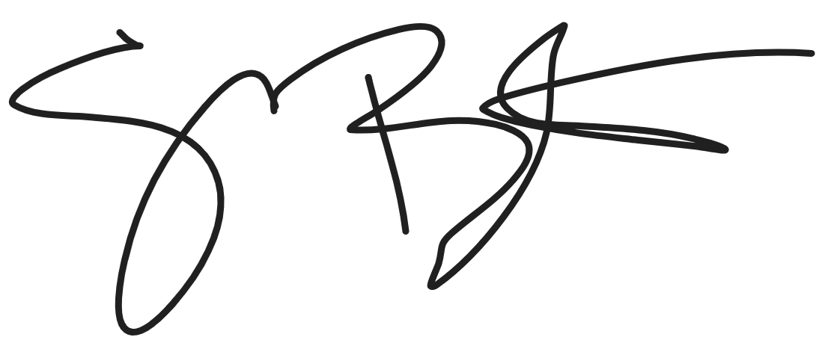
Shelly Boster
City Clerk

Date Minutes Approved: 7/27/2023

