Special City Council Meeting
City Of Virden
City Council Chambers
Thursday May 18, 2023

Meeting called to order by Mayor Murphy at 7:26 pm.

Roll Call:
- The following Council Members were present: Bertolino, Boster, Calloway, Cunningham, Ibberson, Mitchell, and Mottershaw
- Absent: Neighbors
Also present were: Mayor Murphy, City Clerk Shelly Boster, Public Work director Gary Etter

Topics:
- Waive bidding for Stoddard St demolition
Motion made by Mitchell seconded by Bertolino to waive bidding for the Stoddard St house.
Discussion: Murphy: We originally approved City of Virden to demolish the house on Stoddard St that is now the property of the City of Virden. Mark did further investigation and found an excavation company from Carlinville that would do the whole thing including cap to the sewer/water, backfilling, and seeding.
Motion passed with all in favor. Ayes: Bertolino, Boster, Calloway, Cunningham, Ibberson, Mitchell, and Mottershaw Nays: None; Absent: Neighbors

- Approve Cole Excavation to demolish Stoddard St house
Motion made by Mottershaw seconded by Boster to approve Cole excavating from Carlinville to demolish and remove house located at 135 East Stoddard St. for $9000.00
Discussion: Bertolino: Liability Insurance has been provided and bid quote acquired.
Motion passed with all in favor. Ayes: Bertolino, Boster, Calloway, Cunningham, Ibberson, Mitchell, and Mottershaw Nays: None; Absent: Neighbors

- Hire summer help for Public Works
Appointment of Jacob Bickel and Joe June as seasonal part-time employees for public works department beginning June 1, 2023, through August 31, 2023, at $13.00/hr. was made by Mayor Murphy.
Motion made by Mottershaw seconded by Bertolino to accept the appointment of Jacob Bickel and Joe June.
Discussion: None
Motion passed with all in favor. Ayes: Bertolino, Boster, Cunningham, Ibberson, Mitchell, and Mottershaw Nays: None; Abstain: Calloway; Absent: Neighbors

Motion made by Murphy seconded by Mottershaw to enter executive session at 7:31 pm to discuss Buying and selling of property and personnel.
Discussion: None
Motion passed with all in favor. Ayes: Bertolino, Boster, Calloway, Cunningham, Ibberson, Mitchell, and Mottershaw Nays: None; Absent: Neighbors

Executive Session:
- Buy/Sell property, personnel, if needed

Motion made by Mottershaw seconded by Boster to exit executive session at 7:53 pm.
Discussion: None
Motion passed with all in favor. Ayes: Bertolino, Boster, Calloway, Cunningham, Ibberson, Mitchell, and Mottershaw Nays: None; Absent: Neighbors

Additional:
None

Motion made by Mottershaw second by Bertolino to adjourn at 7:56 pm.
Discussion: None
Motion passed with all in favor. Ayes: Bertolino, Boster, Calloway, Cunningham, Ibberson, Mitchell, and Mottershaw Nays: None; Absent: Neighbors

Meeting adjourned at 7:56 pm.

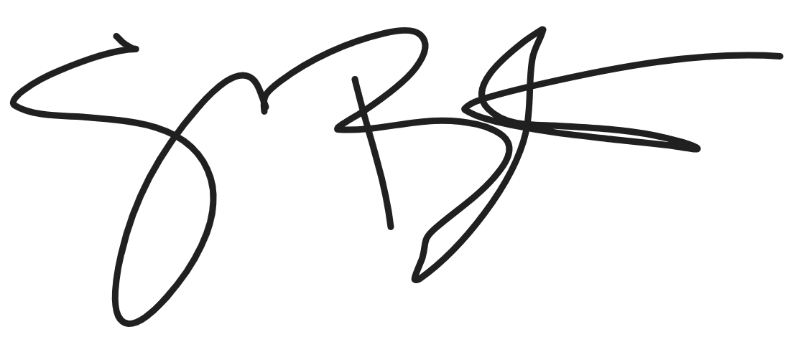
Shelly Boster
City Clerk

Date Minutes Approved: 6/5/2023

