Regular City Council Meeting
Official Proceedings
City of Virden, IL
Virden City Council Chambers
Monday, May 1, 2023

Regular City Council Meeting (Old Council) was called to order by Mayor George Murphy on May 1, 2023, at 7:00pm.

Pledge of Allegiance

Roll Call:
- The following Council Members were present: Bertolino, Calloway, Mitchell, Mottershaw, and Neighbors

- Absent: Sharp and Maguire

- Also present were Mayor George Murphy, City Clerk Shelly Boster, Deputy Treasurer/Bookkeeper Barry Liss, City Manager Madonna Lackey, Attorney Don Craven, and Attorney Joe Craven

- Guest: Terry Davis, Joshua Ronan, Michael Maurer, Judy Hendricks, Anthony Boster, Lisa Cunningham, and Evan Ibberson

Old Business
Approval of Agenda (5-1-2023):
Motion made by Mitchell second by Calloway to approve the agenda as amended (5-1-2023).
Discussion: Murphy: Number 1 under Mayor can be removed. That is complete. Mottershaw: I want to add for discussion only under Administration Number 3 Application for boring permit.
Motion passed with all in favor. Ayes: Bertolino, Calloway, Mitchell, Mottershaw, and Neighbors Nays: None; Absent: Maguire and Sharp

Approval of Meeting Minutes (Council Meeting 4-3-23 and Special City Council meeting 4-20-23)
Motion made by Mitchell second by Calloway to approve City Council Meeting Minutes 4-3-23 and Special City Council meeting 4-20-23.
Discussion: None
Motion passed with all in favor. Ayes: Bertolino, Calloway, Mitchell, Mottershaw, and Neighbors Nays: None; Absent: Maguire and Sharp

Approval of Bills Payable:
Motion made by Mitchell second by Calloway to approve bills payable.
Discussion: Murphy: I do want to mention we did receive another bill for Hinshaw and Culbertson. It is under Street and Alleys for $2,470.00 for Ester Seitz. Also William Lane for the appraisal.
Motion passed with all in favor. Ayes: Bertolino, Calloway, Mitchell, Mottershaw, and Neighbors Nays: None; Absent: Maguire and Sharp

Treasurer’s Report:
Motion made by Mottershaw second by Mitchell to approve treasurer’s report for March 2023
Discussion: None
Motion passed with all in favor. Ayes: Bertolino, Calloway, Mitchell, Mottershaw, and Neighbors Nays: None; Absent: Maguire and Sharp

Water Report (March 2023 Gallons report and April 2023 Collections report):
Motion made by Mottershaw second by Mitchell to approve March 2023 Gallons and April 2023 Collections report.
Discussion: Mottershaw: We met with people from Badger. We are looking at every possibility. We have eliminated a leak.
Motion passed with all in favor. Ayes: Bertolino, Calloway, Mitchell, Mottershaw, and Neighbors Nays: None; Absent: Maguire and Sharp

Mayor:

- Thanks to outgoing elected/appointed officials.
Murphy: I would like to thank Betty Maguire and Bill Sharp for their years of service.

Adjourn Sine Die
Motion made by Mitchell second by Neighbors to adjourn Sine Die with old council at 7:09 pm.
Discussion: None
Motion passed with all in favor. Ayes: Bertolino, Calloway, Mitchell, Mottershaw, and Neighbors Nays: None; Absent: Maguire and Sharp

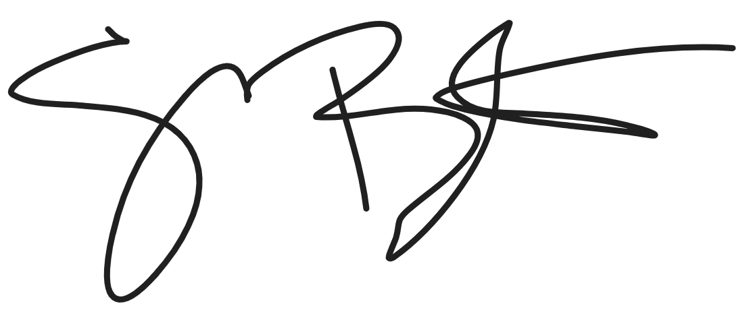

Shelly Boster
City Clerk

Date Minutes Approved: 6/5/2023

